BUDO JUNIOR SCHOOL
REMEDIAL WORK FOR TERM 1 2020 - SET TWO
RELIGIOUS EDUCATION FOR PRIMARY TWO

Name: _________________________________________________________________________
Stream: ________________ Date: _________________________________________

SECTION A
1. Mary was the mother of _________________ .

2. Father heads a __________________________.

3. ________________________ is my religious name.

4. A ___________________ is a special way of talking to God. ( prayer , singing)

5. Priests uses ___________________ to baptize people.

6. What is the holy book for Christians?
_________________________________________________________________

7. We go to church to __________________ ( pray , play)

8. Who baptized Jesus?
_________________________________________________________________

9. What do we get from these domestic animals?
cow: (i) - ______________________ (ii) ______________________

hens (i) _______________________ (ii) _______________________

9. Name these materials we use to clean the church compound.
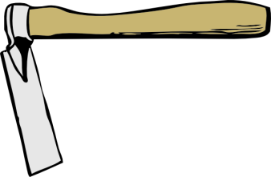 | 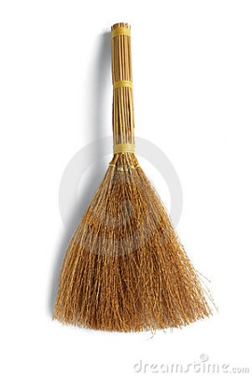 | 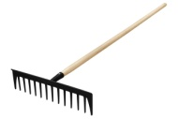

11. Match God’s people with their place of work.

barber school
police man hospital
teacher salon
doctor police station

12. God gave me my body parts.
Give the uses of these body parts.
legs : _____________________________________________________________

mouth ; ___________________________________________________________

nose : _____________________________________________________________

13. On which day do Muslims go for Juma prayers?
____________________________________________________________________

14. Write the Christians names for boys and girls.
boys girls
- ____________________ 1. ________________________
- ____________________ 2. ________________________
- ____________________ 3. ________________________

15. Name these religious symbols.
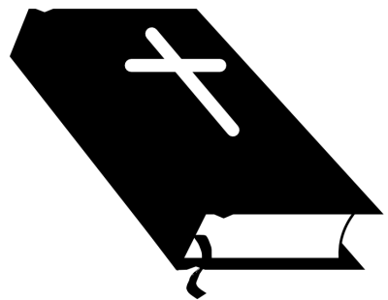 | 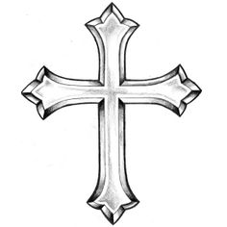

16. God wants us to be clean.
Draw these things we use to be clean.
tooth brush | water | comb

17. Write one thing we ask for in our Lord’s Prayer.
_________________________________________________________________

18. How do we call the prayer which Jesus taught us?
___________________________________________________________________

19. Give 2 reasons why we pray.
(i) ___________________________________________________________________
(ii) ___________________________________________________________________
19. Name 2 places we can pray from.
(i)__________________________ (ii)______________________________

20. ________________________ was nailed on the cross.

21. On which day was Jesus killed on the cross.
___________________________________________________________________

22. _______________________ betrayed Jesus. ( Moses , Judas)

23. Match these animals which God created with their young ones.

cat kid
sheep piglet
goat kitten
pig lamb

24. The day on which Jesus rose from the dead is called
________________________________________( Christmas Day , Easter Day )

25. We should ___________________ our neighbours. ( kill , love )

26. Draw a Good Samaritan helping a man who was beaten.

